**DATA PREPROCESSING**

**IMPORT THE NECESSARY LIBRARIES**

**import** pandas **as** pd

**import** numpy **as** np

**import** matplotlib.pyplot **as** plt

**import** seaborn **as** sns

**import** sklearn

**IMPORT THE DATASET**

In [13]:

df**=**pd**.**read_csv('Churn_Modelling.csv')

In [14]:

df**.**head()

Out[14]:

|  |  |  |  |  |  |  |  |  |  |  |  |  |  |
| --- | --- | --- | --- | --- | --- | --- | --- | --- | --- | --- | --- | --- | --- |

RowNumber CustomerId Surname CreditScore Geography Gender Age Tenure Balance NumOfProducts HasCrCard IsActiveMember EstimatedSalary Exited

0 1 15634602 Hargrave 619 France Female 42 2 0.00 1 1 1 101348.88 1

1 2 15647311 Hill 608 Spain Female 41 1 83807.86 1 0 1 112542.58 0

2 3 15619304 Onio 502 France Female 42 8 159660.80 3 1 0 113931.57 1

3 4 157013sns**.**displot(df['EstimatedSalary'])

Out[15]:

54 Boni 699 France Female 39 1 0.00 2 0 0 93826.63 0

4 5 15737888 Mitchell 850 Spain Female 43 2 125510.82 1 1 1 79084.10 0

**VISUALIZATION:**

sns.displot(df['EstimatedSalary'])

Out[15]:

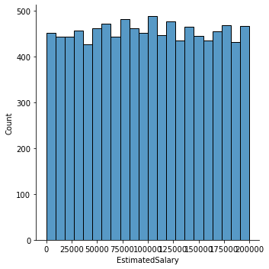

**univariate analysis**

df.CreditScore.plot()

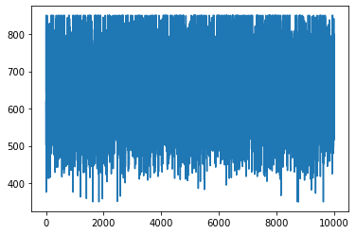

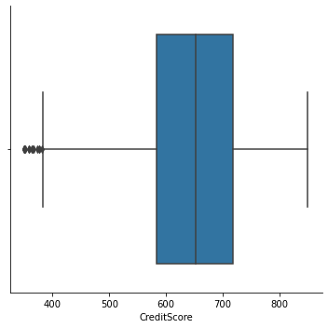

sns**.**catplot(x**=**'CreditScore', kind**=**'box',data**=**df)

df[1:10]**.**groupby(['CustomerId'])**.**sum()**.**plot(kind**=**'pie',y**=**'CreditScore')

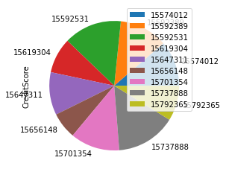

sns**.**scatterplot(df**.**CustomerId,df**.**Tenure)

plt**.**show()

C:\Users\DELL i5-3593\anaconda3\lib\site-packages\seaborn\_decorators.py:36: FutureWarning: Pass the following variables as keyword args: x, y. From version 0.12, the only valid positional argument will be `data`, and passing other arguments without an explicit keyword will result in an error or misinterpretation.

warnings.warn(

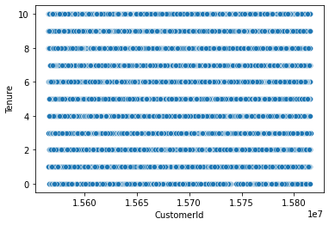

**Multivariate Analysis**

df**.**plot()

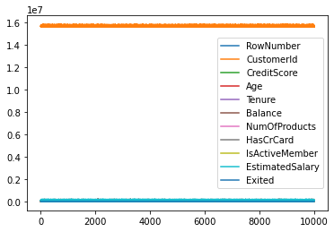

*#bivariate analysis*

df**.**CreditScore[1:10]**.**plot()

df**.**Balance[1:10]**.**plot()

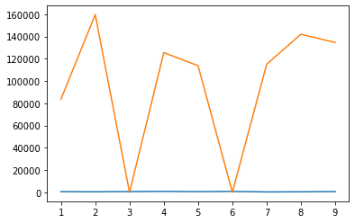

**DESCRIPTIVE ANALYSIS**

df**.**describe()

|  | **RowNumber** | **CustomerId** | **CreditScore** | **Age** | **Tenure** | **Balance** | **NumOfProducts** | **HasCrCard** | **IsActiveMember** | **EstimatedSalary** | **Exited** |
| --- | --- | --- | --- | --- | --- | --- | --- | --- | --- | --- | --- |
| **count** | 10000.00000 | 1.000000e+04 | 10000.000000 | 10000.000000 | 10000.000000 | 10000.000000 | 10000.000000 | 10000.00000 | 10000.000000 | 10000.000000 | 10000.000000 |
| **mean** | 5000.50000 | 1.569094e+07 | 650.528800 | 38.921800 | 5.012800 | 76485.889288 | 1.530200 | 0.70550 | 0.515100 | 100090.239881 | 0.203700 |
| **std** | 2886.89568 | 7.193619e+04 | 96.653299 | 10.487806 | 2.892174 | 62397.405202 | 0.581654 | 0.45584 | 0.499797 | 57510.492818 | 0.402769 |
| **min** | 1.00000 | 1.556570e+07 | 350.000000 | 18.000000 | 0.000000 | 0.000000 | 1.000000 | 0.00000 | 0.000000 | 11.580000 | 0.000000 |
| **25%** | 2500.75000 | 1.562853e+07 | 584.000000 | 32.000000 | 3.000000 | 0.000000 | 1.000000 | 0.00000 | 0.000000 | 51002.110000 | 0.000000 |
| **50%** | 5000.50000 | 1.569074e+07 | 652.000000 | 37.000000 | 5.000000 | 97198.540000 | 1.000000 | 1.00000 | 1.000000 | 100193.915000 | 0.000000 |
| **75%** | 7500.25000 | 1.575323e+07 | 718.000000 | 44.000000 | 7.000000 | 127644.240000 | 2.000000 | 1.00000 | 1.000000 | 149388.247500 | 0.000000 |
| **max** | 10000.00000 | 1.581569e+07 | 850.000000 | 92.000000 | 10.000000 | 250898.090000 | 4.000000 | 1.00000 | 1.000000 | 199992.480000 | 1.000000 |

df**.**isnull()**.**any()

RowNumber False

CustomerId False

Surname False

CreditScore False

Geography False

Gender False

Age False

Tenure False

Balance False

NumOfProducts False

HasCrCard False

IsActiveMember False

EstimatedSalary False

Exited False

dtype: bool

df**.**isnull()**.**sum()

RowNumber 0

CustomerId 0

Surname 0

CreditScore 0

Geography 0

Gender 0

Age 0

Tenure 0

Balance 0

NumOfProducts 0

HasCrCard 0

IsActiveMember 0

EstimatedSalary 0

Exited 0

dtype: int64

**HANDLING VALUES**

sns**.**heatmap(df**.**corr(),annot**=True**)

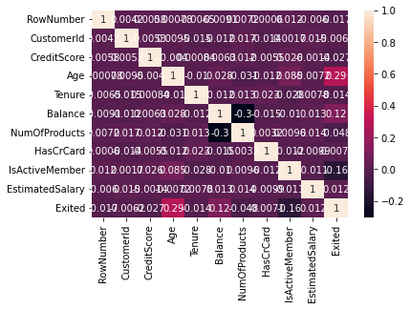

**OUTLIERS**

sns**.**boxplot(df**.**CreditScore)

C:\Users\DELL i5-3593\anaconda3\lib\site-packages\seaborn\_decorators.py:36: FutureWarning: Pass the following variable as a keyword arg: x. From version 0.12, the only valid positional argument will be `data`, and passing other arguments without an explicit keyword will result in an error or misinterpretation.

warnings.warn(

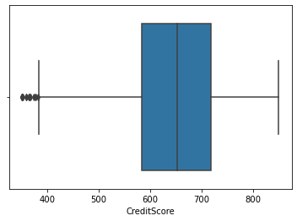

Q1**=**df**.**Cre

ditScore**.**quantile(0.25)

Q3**=**df**.**CreditScore**.**quantile(0.75)

IQR**=**Q3**-**Q1

upper_limit**=**Q3**+**1.5**\***IQR

lower_limit**=**Q1**-**1.5**\***IQR

df['CreditScore']**=**np**.**where(df['CreditScore']**>**upper_limit,30,df['CreditScore'])

sns**.**boxplot(df**.**CreditScore)

C:\Users\DELL i5-3593\anaconda3\lib\site-packages\seaborn\_decorators.py:36: FutureWarning: Pass the following variable as a keyword arg: x. From version 0.12, the only valid positional argument will be `data`, and passing other arguments without an explicit keyword will result in an error or misinterpretation.

warnings.warn(



Categorical Columns Encoding

from sklearn.preprocessing import LabelEncoder

le=LabelEncoder()

df.Gender=le.fit_transform(df.Gender)

df.head(5)

RowNumber CustomerId Surname CreditScore Geography Gender Age Tenure Balance NumOfProducts HasCrCard IsActiveMember EstimatedSalary Exited

0 1 15634602 Hargrave 619 France 0 42 2 0.00 1 1 1 101348.88 1

1 2 15647311 Hill 608 Spain 0 41 1 83807.86 1 0 1 112542.58 0

2 3 15619304 Onio 502 France 0 42 8 159660.80 3 1 0 113931.57 1

3 4 15701354 Boni 699 France 0 39 1 0.00 2 0 0 93826.63 0

4 5 15737888 Mitchell 850 Spain 0 43 2 125510.82 1 1 1 79084.10 0

df_main=pd.get_dummies(df,columns=['Geography'])

df_main.head()

**SEPARATING INDEPENDENT AND DEPENDENT VARIABLES**

X**=**df_main**.**drop(columns**=**['EstimatedSalary'],axis**=**1)

X**.**head()

X_scaled**=**pd**.**DataFrame(scale(X),columns**=**X**.**columns)

X_scaled**.**head()

**---------------------------------------------------------------------------**

**NameError** Traceback (most recent call last)

**C:\Users\DELLI5~1\AppData\Local\Temp/ipykernel_13384/464208997.py** in

1 X**=**df_main**.**drop**(**columns**=['EstimatedSalary'],**axis**=1)**

2 X**.**head**()**

**----> 3** X_scaled**=**pd**.**DataFrame**(**scale**(**X**),**columns**=**X**.**columns**)**

4 X_scaled**.**head**()**

**NameError**: name 'scale' is not defined

y**=**Df_main**.**EstimatedSalary

y

**---------------------------------------------------------------------------**

**NameError** Traceback (most recent call last)

**C:\Users\DELLI5~1\AppData\Local\Temp/ipykernel_13384/912569982.py** in

**----> 1** y**=**Df_main**.**EstimatedSalary

2 y

**NameError**: name 'Df_main' is not defined

**SCALING**

**from** sklearn.preprocessing **import** scale

X_scaled**=**pd**.**DataFrame(scale(X),columns**=**X**.**columns)

X_scaled**.**head()

**---------------------------------------------------------------------------**

**ValueError** Traceback (most recent call last)

**C:\Users\DELLI5~1\AppData\Local\Temp/ipykernel_13384/883186635.py** in

**----> 1** X_scaled**=**pd**.**DataFrame**(**scale**(**X**),**columns**=**X**.**columns**)**

2 X_scaled**.**head**()**

**~\anaconda3\lib\site-packages\sklearn\utils\validation.py** in inner_f**(*args, **kwargs)**

61 extra_args **=** len**(**args**)** **-** len**(**all_args**)**

62 **if** extra_args **<=** **0:**

**---> 63 return** f**(\***args**,** **\*\***kwargs**)**

64

65 **# extra_args > 0**

**~\anaconda3\lib\site-packages\sklearn\preprocessing\_data.py** in scale**(X, axis, with_mean, with_std, copy)**

159

160 """ # noqa

**--> 161 X = check_array(X, accept_sparse='csc', copy=copy, ensure_2d=False,**

162 estimator**='the scale function',** dtype**=**FLOAT_DTYPES**,**

163 force_all_finite='allow-nan')

**~\anaconda3\lib\site-packages\sklearn\utils\validation.py** in inner_f**(*args, **kwargs)**

61 extra_args **=** len**(**args**)** **-** len**(**all_args**)**

62 **if** extra_args **<=** **0:**

**---> 63 return** f**(\***args**,** **\*\***kwargs**)**

64

65 **# extra_args > 0**

**~\anaconda3\lib\site-packages\sklearn\utils\validation.py** in check_array**(array, accept_sparse, accept_large_sparse, dtype, order, copy, force_all_finite, ensure_2d, allow_nd, ensure_min_samples, ensure_min_features, estimator)**

671 array **=** array**.**astype**(**dtype**,** casting**="unsafe",** copy**=False)**

672 **else:**

**--> 673** array **=** np**.**asarray**(**array**,** order**=**order**,** dtype**=**dtype**)**

674 **except** ComplexWarning **as** complex_warning**:**

675 raise ValueError("Complex data not supported\n"

**~\anaconda3\lib\site-packages\numpy\core\_asarray.py** in asarray**(a, dtype, order, like)**

100 **return** _asarray_with_like**(**a**,** dtype**=**dtype**,** order**=**order**,** like**=**like**)**

101

**--> 102 return** array**(**a**,** dtype**,** copy**=False,** order**=**order**)**

103

104

**~\anaconda3\lib\site-packages\pandas\core\generic.py** in __array__**(self, dtype)**

1991

1992 **def** __array__**(**self**,** dtype**:** NpDtype **|** **None** **=** **None)** **->** np**.**ndarray**:**

**-> 1993 return** np**.**asarray**(**self**.**_values**,** dtype**=**dtype**)**

1994

1995 def __array_wrap__(

**~\anaconda3\lib\site-packages\numpy\core\_asarray.py** in asarray**(a, dtype, order, like)**

100 **return** _asarray_with_like**(**a**,** dtype**=**dtype**,** order**=**order**,** like**=**like**)**

101

**--> 102 return** array**(**a**,** dtype**,** copy**=False,** order**=**order**)**

103

104

**ValueError**: could not convert string to float: 'Hargrave'

**TRAIN AND TEST DATA**

**from** sklearn.model_selection **import** train_test_split

X_train,X_test,y_train,y_test **=**train_test_split(X_scaled,y, test_size**=**0.3,random_state**=**0)

**---------------------------------------------------------------------------**

**NameError** Traceback (most recent call last)

**C:\Users\DELLI5~1\AppData\Local\Temp/ipykernel_13384/3510837689.py** in

1 **from** sklearn**.**model_selection **import** train_test_split

**----> 2** X_train**,**X_test**,**y_train**,**y_test **=**train_test_split**(**X_scaled**,**y**,** test_size**=0.3,**random_state**=0)**

**NameError**: name 'X_scaled' is not defined

X_train**.**shape

**---------------------------------------------------------------------------**

**NameError** Traceback (most recent call last)

**C:\Users\DELLI5~1\AppData\Local\Temp/ipykernel_13384/4225672638.py** in

**----> 1** X_train**.**shape

**NameError**: name 'X_train' is not defined

X_test**.**shape

**---------------------------------------------------------------------------**

**NameError** Traceback (most recent call last)

**C:\Users\DELLI5~1\AppData\Local\Temp/ipykernel_13384/3624294392.py** in

**----> 1** X_test**.**shape

**NameError**: name 'X_test' is not defined

y_train**.**shape

**---------------------------------------------------------------------------**

**NameError** Traceback (most recent call last)

**C:\Users\DELLI5~1\AppData\Local\Temp/ipykernel_13384/3798806461.py** in

**----> 1** y_train**.**shape

**NameError**: name 'y_train' is not defined

y**.**train**.**shape

**NameError** Traceback (most recent call last)

**C:\Users\DELLI5~1\AppData\Local\Temp/ipykernel_13384/830994784.py** in

**----> 1** y**.**train**.**shape

**NameError**: name 'y' is not defined